**DEALINGS IN PROPERTIES**

1. **Summary**

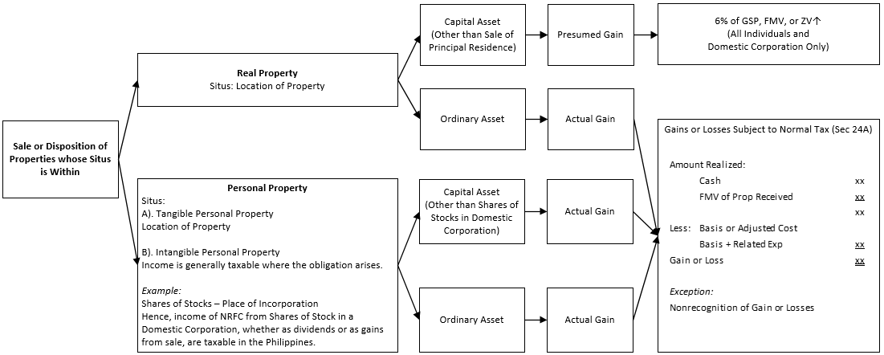

Note:

Sale or disposition of properties without are subject to normal tax whether classified as personal or real, capital or ordinary asset.

1. **Dealings in Real Properties**

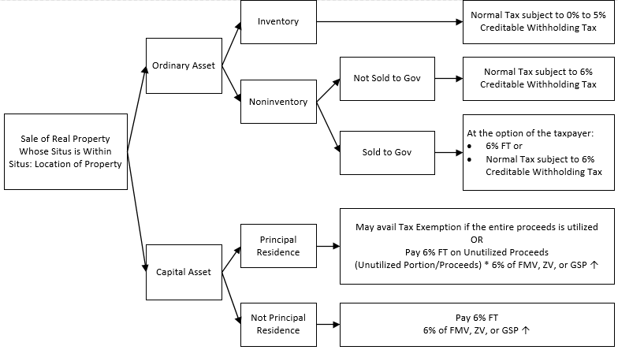

Note:

Sale or disposition of real properties without are subject to normal tax whether classified as capital or ordinary asset. (Ref: Income Taxation by Edwin G. Valencia 5th Ed p. 336)

1. **Dealing in Shares of Stocks in Domestic Corporation**

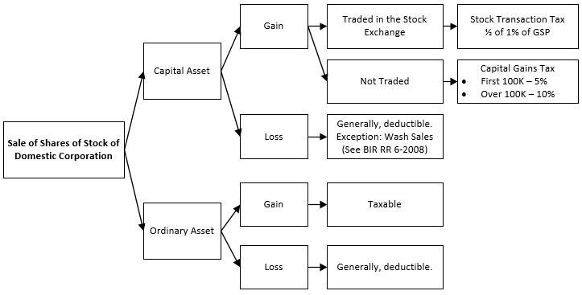

Note:

Sale of Shares of Stock in Foreign Corporation are considered with situs without hence subject to normal tax whether classified as capital or ordinary asset.

|  |  |  |  |  |  |  |
| --- | --- | --- | --- | --- | --- | --- |
| **Wash Sales**  *Formulas*   1. Amount of Nondeductible Loss   Nondeductible Loss = Amount of Loss * (# of shares bought during prohibited period/# of shares sold)  Prohibitive period = Within 30 days before or after the sale of stocks at a loss.   1. Tax Basis of Reacquired Shares  |  |  | | --- | --- | | Cost of acquisition | xx | | Add: Wash sale loss | xx | | Tax basis or cost | xx | |

1. **Installment Payment of Tax**

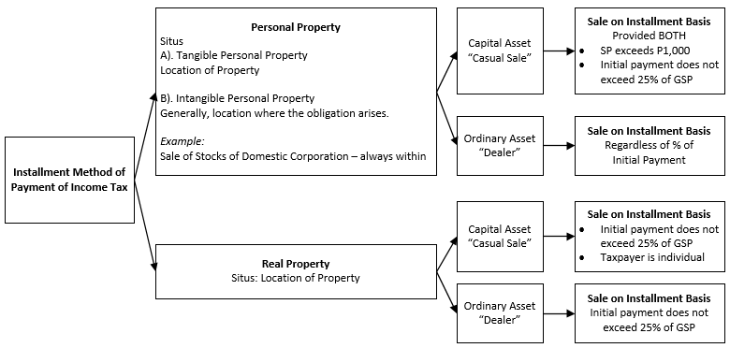

|  |  |  |  |  |  |  |  |  |  |  |  |  |  |  |  |  |  |  |  |  |  |  |  |  |  |  |  |  |  |  |  |  |  |  |  |  |  |  |  |  |
| --- | --- | --- | --- | --- | --- | --- | --- | --- | --- | --- | --- | --- | --- | --- | --- | --- | --- | --- | --- | --- | --- | --- | --- | --- | --- | --- | --- | --- | --- | --- | --- | --- | --- | --- | --- | --- | --- | --- | --- | --- |
| **Formulas on Installment Payment of Tax**   1. *Income Tax to be Reported* 2. If the property sold is subject to normal tax  |  |  |  |  |  | | --- | --- | --- | --- | --- | | Income to be Reported | = | Gross Profit | x | Initial Payment on Date of Sale or  Amount of Subsequent Collection Received | | Contract Price |  1. If the property is subject to capital gains tax  |  |  |  |  |  | | --- | --- | --- | --- | --- | | CGT to be Reported | = | CGT | x | Initial Payment on Date of Sale or  Amount of Subsequent Collection Received | | Contract Price |  1. *Initial Payment* 2. No mortgage on property sold or mortgage assumed by buyer does not exceed cost to the seller  |  |  | | --- | --- | | Downpayment | xx | | Add: Additional Payments made during the year | xx | | Initial Payment | xx |  1. Mortgage assumed by buyer exceeds cost to the seller  |  |  | | --- | --- | | Downpayment | xx | | Add: Additional Payments made during the year  Excess of mortgage over cost to Seller | xx  xx | | Initial Payment | xx |  1. *Contract Price* 2. No mortgage   Contract Price = Selling Price   1. Mortgage assumed by buyer does not exceed cost to the seller  |  |  | | --- | --- | | Selling Price | xx | | Less: Mortgage assumed by the buyer | xx | | Contract Price | xx |  1. Mortgage assumed by buyer exceeds cost to the seller  |  |  | | --- | --- | | Selling Price | xx | | Add: Excess of mortgage over cost to Seller | xx | | Total | xx | | Less: Mortgage assumed by the buyer | xx | | Contract Price | xx | |

1. **Relevance of Determining Capital Asset from Ordinary Asset**
2. **Holding Period of Capital Asset**

|  |  |  |
| --- | --- | --- |
|  | **Reportable Capital Gain or Loss** | |
| **Holding Period** | **Individuals** | **Corporations** |
| Not more than 12 months | 100% | 100%  Rule on holding period not applicable. |
| More than 12 months | 50% |

Note:

Rule is not applicable on the following sale transactions:

* Sale or exchange of real properties classified as capital asset.
* Sale or exchange of shares of stocks classified as capital asset (RA 6-2008 Sec 7.c.4)

1. **Limitations on Capital Losses**

A capital loss can only be deducted from capital gains but never from an ordinary gain, while an ordinary loss may deducted from both capital and ordinary gain. Applicable to individual and corporations.

|  |  |  |
| --- | --- | --- |
|  | **Deductible from** | |
| **Type of Loss** | **Ordinary Gains** | **Capital Gains** |
| Ordinary Losses | Yes | Yes |
| Capital Losses | No | Yes |

1. **Net Capital Loss Carry-Over**

A capital loss may only be deducted from a capital gain, if there is any. What then is the remedy of the taxpayer where is capital loss but there is no capital gain?

Apply the NCLCO Rule. Note that this is different from the NOLCO Rule.

**NCLCO Rule**

* Any capital loss sustained by the taxpayer during a taxable year shall be treated in the succeeding taxable year as a loss from sale or exchange of capital asset held for not more than 12 months.
* Requisites
* Amount of loss should not exceed net income for the taxable year when the loss was incurred.
* There should be capital gain from which the carried over loss can be deducted
* Can only be availed by individuals!